COMPLAINT MANAGEMENT SYSTEM
A Synopsis
Submitted in partial fulfillment of the Requirement of the award of the degree of
BACHELOR OF COMPUTER APPLICATIONS
By
ALOK KUMAR
ROLL NO. : 247322010025

FACULTY NAME
Mr. Anuj Kakran
S. D. COLLEGE OF MANAGEMENT STUDIES, MUZAFFARNAGAR
Affiliated to Maa Shakumbhari University, Saharanpur
MUZAFFARNAGAR, 251001
UTTAR PRADESH
2026

S. D. COLLEGE OF MANAGEMENT STUDIES, MUZAFFARNAGER
Affiliated to Maa Shakumbhari University, Saharanpur MUZAFFARNAGER,
251001
BACHELOR OF COMPUTER APPLICATIONS

CERTIFICATE
This is to certify that the project entitled, "COMPLAINT MANAGEMENT SYSTEM", is bona fide work of ALOK KUMAR bearing Roll No.: 247322010025 submitted in partial fulfillment of the requirements for the award of the degree of BACHELOR OF COMPUTER APPLICATIONS from Maa Shakumbhari University, Saharanpur.

Name of Internal Guide Name of Coordinator
Mr. Anuj Kakran Mr. Mohit Kumar

Name of HOD
Dr. Sanjeev Tayal

Date: __________________ College Seal

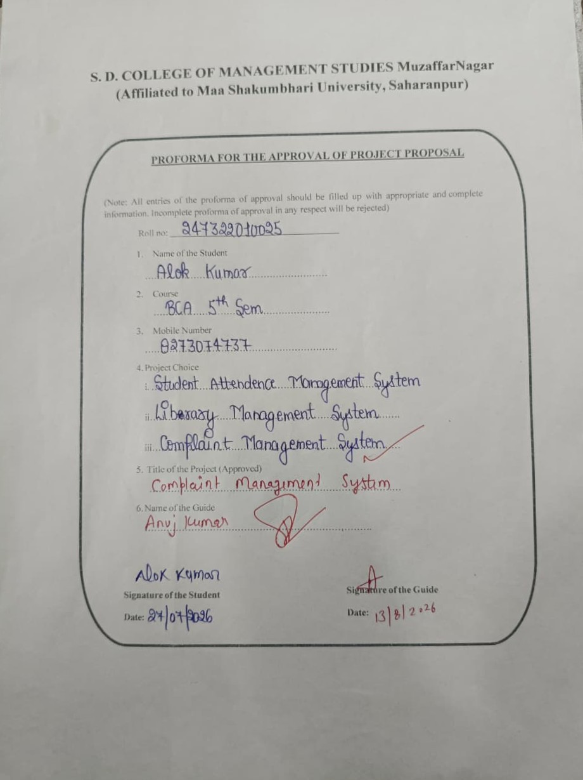
ABSTRACT
The Complaint Management System is a web-based application designed to provide a simple and organized platform for registering, tracking, managing, and resolving complaints. The system allows users to submit complaints by providing relevant details such as complaint title, description, category, and date. It helps the concerned administrator or authorized staff to view and manage complaints efficiently.
The application provides an easy-to-use interface through which users can check the status of their complaints. The administrator can view submitted complaints, update their status, assign complaints to the concerned department or person, and maintain complaint records digitally.
The main objective of the project is to reduce manual complaint handling, improve transparency, minimize delays, and provide a convenient way for users and administrators to manage complaints. The system can be developed using HTML, CSS, JavaScript, and a suitable backend/database according to project requirements.

ACKNOWLEDGEMENT
I would like to express my sincere gratitude to all those who have supported and guided me throughout the development of my project entitled “Complaint Management System.”
First and foremost, I would like to express my heartfelt thanks to my Project Mentor, Mr. Anuj Kakran, for his valuable guidance, continuous support, constructive suggestions, and encouragement throughout the project. His guidance helped me understand the project requirements and complete the work in a systematic manner.
I am deeply grateful to my Head of the Department, Dr. Sanjeev Tayal, for his valuable support, encouragement, and guidance throughout the project.
I am also thankful to all the faculty members of S. D. College of Management Studies, Muzaffarnagar, for their valuable suggestions, cooperation, and academic support.
I would also like to thank my college for providing me with the necessary facilities, resources, and learning environment to carry out this project successfully.
Finally, I express my sincere gratitude to my family and friends for their constant encouragement, support, and motivation throughout the project.
Thank You.

DECLARATION
I hereby declare that the project entitled “Complaint Management System” done at S. D. College of Management Studies, Muzaffarnagar has not been duplicated or submitted to any other university for the award of any degree.
To the best of my knowledge, no one other than me has submitted this project to any other university for the award of any degree.
The project is done in partial fulfillment of the requirements for the award of the degree of BACHELOR OF COMPUTER APPLICATIONS to be submitted as a V Semester Project as part of the curriculum.
Name of the Student: Alok Kumar
Roll No: 247322010025
Signature of the Student: ____________________

INDEX
S. No. | Contents | Page No.
1 | Introduction / Background | 1
2 | Problem Statement | 2
3 | Objectives of the Project | 3
4 | Literature Review / Existing System | 4
5 | Proposed System / Proposed Solution | 5
6 | Methodology | 6
7 | Scope of the Project | 7
8 | Technologies / Tools Required | 8
9 | Expected Outcomes | 9
10 | References | 10
LIST OF TABLES
Table 1 -------- TECHNOLOGIES / TOOLS REQUIRED -------- Page No. 9

LIST OF FIGURES
Figure 1 -------- SYSTEM WORKFLOW / ARCHITECTURE -------- Page No. 5
Figure 2 -------- DATA FLOW DIAGRAM (DFD) -------- Page No. 5

CHAPTER 1
INTRODUCTION
The Complaint Management System is a web-based application developed to provide a simple, convenient, and efficient platform for registering and managing complaints digitally. In many organizations and institutions, complaints are still handled manually through registers, paper forms, or informal communication. Such methods can make it difficult to track complaints, maintain records, and know the current status of a complaint.
The proposed system allows users to submit complaints by entering necessary information such as complaint title, category, description, and other required details. Once a complaint is submitted, the authorized administrator can view it, update its status, and take appropriate action.
The system also helps maintain complaint records in an organized manner. Users can check the status of their submitted complaints, while administrators can monitor pending, in-progress, and resolved complaints.
The main aim of the system is to reduce manual effort, improve transparency, provide faster complaint handling, and maintain complaint information digitally.

CHAPTER 2
PROBLEM STATEMENT
The traditional complaint handling process can be time-consuming and inconvenient. Complaints may be submitted through paper forms, registers, or verbal communication, which can make tracking and maintaining records difficult.
The major problems are:
- Manual complaint registration
- Difficulty in tracking complaint status
- Time-consuming complaint management
- Manual maintenance of complaint records
- Possibility of errors or loss of complaint information
- Difficulty in identifying pending and resolved complaints
- Lack of transparency in the complaint resolution process
Therefore, there is a need for a computerized system that can make complaint registration, tracking, management, and resolution easier and more efficient.

CHAPTER 3
OBJECTIVES OF THE PROJECT
The main objectives of the Complaint Management System are:
- To develop an online system for registering and managing complaints.
- To allow users to submit complaints easily.
- To maintain complaint records digitally.
- To provide complaint status tracking.
- To allow administrators to view, update, and manage complaints.
- To categorize complaints and assign them to the concerned person or department.
- To reduce the manual effort involved in complaint management.
- To improve transparency and efficiency in complaint resolution.

CHAPTER 4
LITERATURE REVIEW / EXISTING SYSTEM
The existing complaint management process in many organizations is based on manual methods such as written applications, registers, paper forms, emails, or verbal communication. In such systems, users may not have a convenient way to check the status of their complaints.
Manual systems also require staff to maintain records and search through previous complaints whenever information is required. This can increase the possibility of delays, errors, and loss of records.
Online complaint management systems provide a more convenient approach by allowing complaints to be registered and tracked digitally. The proposed Complaint Management System focuses on providing a simple and user-friendly platform for complaint registration, status tracking, administration, and record management.

CHAPTER 5
PROPOSED SYSTEM / PROPOSED SOLUTION
5.1 Proposed System :-
The proposed Complaint Management System is a web-based application developed to provide a simple and organized platform for submitting and managing complaints. Users can register or log in, submit complaints, provide complaint details, and check their complaint status.
The administrator can view all complaints, filter complaints according to their status or category, assign complaints to the concerned department or person, and update the complaint status.
5.2 System Workflow :- 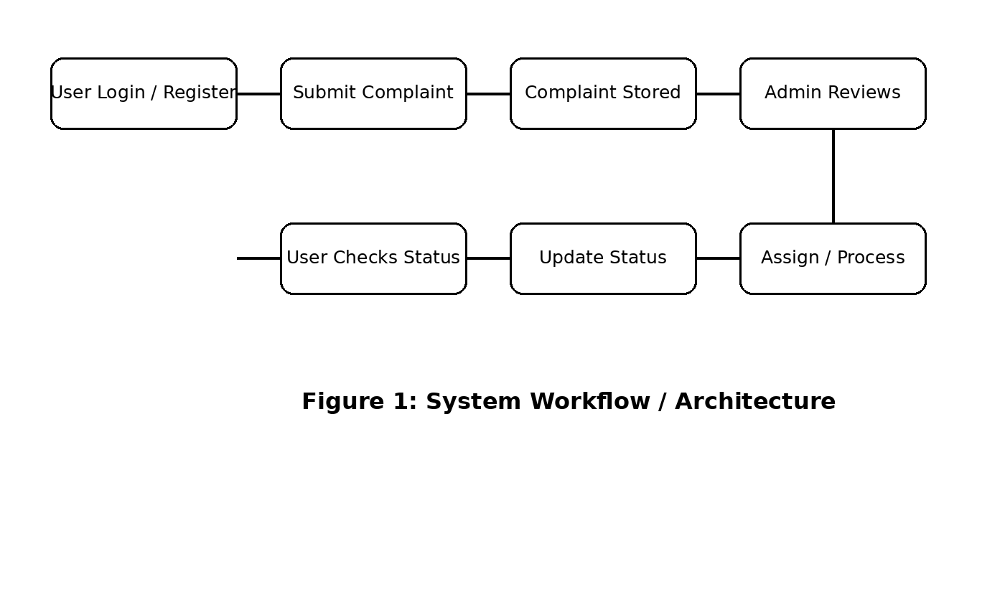
User Login/Register → Submit Complaint → Complaint Stored → Admin Reviews Complaint → Assign/Process Complaint → Update Status → User Checks Status

5.3 Major Modules :-
- User Module – Allows users to register, log in, submit complaints, and view complaint status.
- Complaint Module – Handles complaint registration, category, description, date, and status.
- Admin Module – Allows the administrator to view and manage complaints.
- Assignment Module – Helps assign complaints to the concerned department/person.
- Status Management Module – Maintains statuses such as Pending, In Progress, and Resolved.
- Report/Record Module – Maintains complaint records for future reference.

CHAPTER 6
METHODOLOGY
The development of the Complaint Management System follows a systematic approach to design and implement the web-based application. The main development process consists of the following stages:
- Requirement Analysis
- System Design
- Database Design
- Development
- Testing
- Implementation
- Documentation
During the Requirement Analysis stage, the required features such as complaint registration, login, complaint tracking, status updates, and administration are identified.
During System Design, the application structure, user interface, workflow, and major modules are planned. Database Design is then used to organize user, complaint, category, status, and assignment information.
During Development, the application is implemented using the selected frontend, backend, and database technologies. In the Testing stage, different functions such as complaint submission, login, status update, and record management are tested to identify and correct errors.
Finally, the completed system is implemented and documented as a functional and user-friendly Complaint Management System.
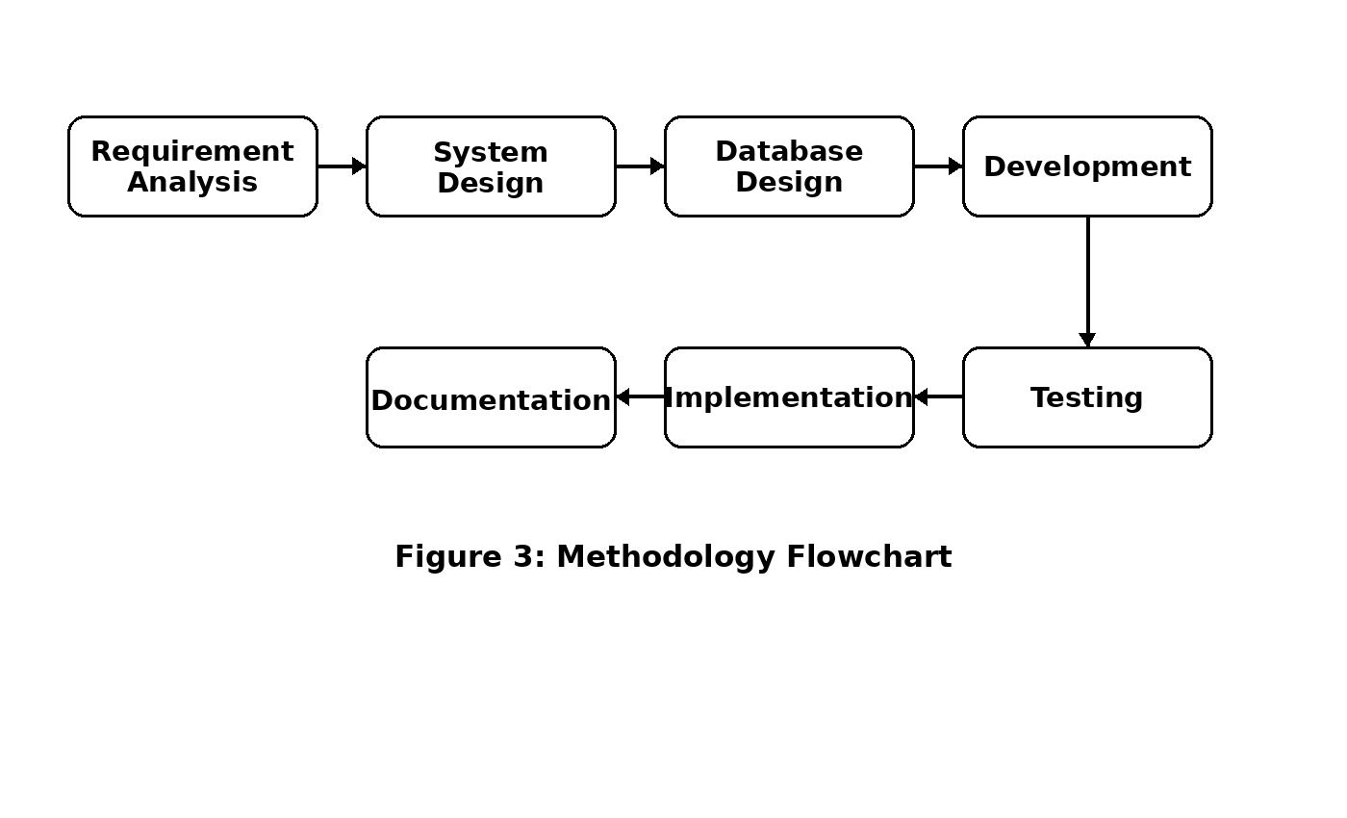
The development flow can be represented as:
Requirement Analysis → System Design → Database Design → Development → Testing → Implementation → Documentation

CHAPTER 7
SCOPE OF THE PROJECT
The Complaint Management System provides a convenient platform for users and administrators to manage complaints digitally. The scope of the project includes:
- User registration and login
- Complaint registration and submission
- Complaint categorization
- Viewing complaint details
- Complaint status tracking
- Admin complaint management
- Assignment of complaints to concerned departments/persons
- Updating complaint status
- Digital storage of complaint records
- Basic complaint reports and record management
The system can be further extended in the future with features such as email/SMS notifications, mobile application support, complaint priority levels, feedback and rating after resolution, dashboards, and advanced reporting.

CHAPTER 8
TECHNOLOGIES/ TOOLS REQUIRED

Component | Technology
Frontend | HTML, CSS, JavaScript
Backend | Python / Django (as required)
Database | MySQL
Development Environment | VS Code
Operating System | Windows
Browser | Google Chrome

CHAPTER 9
EXPECTED OUTCOMES
The expected outcomes of the Complaint Management System are:
- To provide a simple and user-friendly platform for complaint registration.
- To allow users to submit complaints conveniently.
- To maintain complaint information digitally.
- To provide users with complaint status information.
- To help administrators manage complaints in an organized manner.
- To reduce the time and manual effort involved in complaint handling.
- To improve transparency in the complaint resolution process.
- To provide an organized and efficient complaint management experience.

CHAPTER 10
REFERENCES
[1] Python Software Foundation, “Python 3 Documentation,” Python.org. Available at: https://docs.python.org/3/
[2] Django Software Foundation, “Django Documentation,” Django Project. Available at: https://docs.djangoproject.com/
[3] MDN Web Docs, “HTML, CSS and JavaScript Documentation,” Mozilla Developer Network. Available at: https://developer.mozilla.org/
[4] MySQL Documentation, “MySQL Documentation.” Available at: https://dev.mysql.com/doc/

